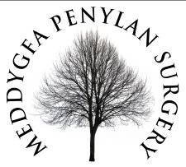

Patient Information - Non NHS/Private fees
Effective 1st March 2023
Patients are advised that General Practitioners are entitled to charge for the following Non NHS/Private service.
All our fees are payable in advance and reflect the BMA guidelines.
Short verification letter  (Including - To Whom It May Concern) | £40
Letter of fitness to (travel/compete/act/dance) | £45
Long verification letter | £60
Private sick note | £40
Travel Cancellation | £60
Private Script | £35
Adoption Forms | £120 per patient
Taxi Medical | £140
HGV Medical | £140
Private Medicals  (Depending on time taken) | £120-£170
Hep B Adult | £45
Hep B Child  (Travel) | £35

Please allow 14 days for completion.

